**Task 1: Single Linked List and Palindrom Function**

**ANSWER**

#include <iostream>

using namespace std;

class Node {

private:

int data;

Node* next;

public:

Node* head;

Node() {

head = NULL;

}

void SLL(int n) {

if (head == NULL) {

head = new Node();

head->data = n;

head->next = NULL;

}

else {

Node* p;

p = new Node();

p->data = n;

p->next = head;

head = p;

}

}

void display() {

Node* ptr;

ptr = head;

if (ptr == NULL) {

cout << " \nNo data is in the list.." << endl;

return;

}

else {

while (ptr != NULL) {

cout << ptr->data << endl;

ptr = ptr->next;

}

}

}

bool isPalindrome() {

if (head == NULL) {

cout << "The list is empty, so it's considered a palindrome." << endl;

return true;

}

Node* fast = head;

Node* slow = head;

Node* prev_slow = head;

Node* mid = NULL;

bool isPalindrome = true;

while (fast != NULL && fast->next != NULL) {

fast = fast->next->next;

prev_slow = slow;

slow = slow->next;

}

if (fast != NULL) {

mid = slow;

slow = slow->next;

}

Node* second_half = slow;

prev_slow->next = NULL;

reverseList(head);

isPalindrome = compareLists(head, second_half);

reverseList(second_half);

if (mid != NULL) {

prev_slow->next = mid;

mid->next = second_half;

} else {

prev_slow->next = second_half;

}

return isPalindrome;

}

void reverseList(Node*& head) {

Node* prev = NULL;

Node* current = head;

Node* next = NULL;

while (current != NULL) {

next = current->next;

current->next = prev;

prev = current;

current = next;

}

head = prev;

}

bool compareLists(Node* head1, Node* head2) {

Node* temp1 = head1;

Node* temp2 = head2;

while (temp1 && temp2) {

if (temp1->data == temp2->data) {

temp1 = temp1->next;

temp2 = temp2->next;

} else {

return false;

}

}

if (!temp1 && !temp2) {

return true;

}

return false;

}

};

int main() {

Node n;

n.SLL(1);

n.SLL(2);

n.SLL(2);

n.SLL(1);

n.display();

if (n.isPalindrome()) {

cout << "The linked list is a palindrome." << endl;

} else {

cout << "The linked list is not a palindrome." << endl;

}

return 0;

}**OUTPUT**

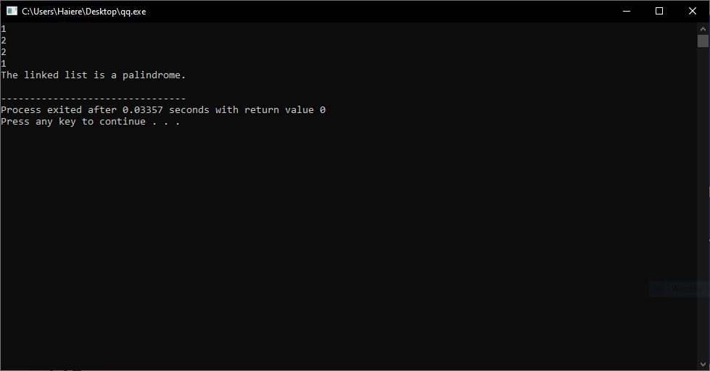

**Task 2: Conditional Branching**

Implement Stack using Array

**ANSWER**

#include <iostream>

using namespace std;

const int SIZE = 100;

class Stack{

private:

int top;

int arr[SIZE];

public:

Stack() {

top = -1;

}

bool isEmpty() {

return top == -1;

}

bool isFull() {

return top == SIZE - 1;

}

void push(int data) {

if (isFull()) {

cout << "Stack is full!!!!!" << endl;

return;

}

arr[++top] = data;

}

void pop() {

if (isEmpty()) {

cout << "Stack is empty!!!!!" << endl;

return;

}

--top;

}

int peek() {

if (isEmpty()) {

cout << "Stack is empty!!!!!" << endl;

return -1;

}

return arr[top];

}

};

int main() {

Stack stack;

cout << "Select an Operation:" << endl;

cout << "1. to Push" << endl;

cout << "2. to Pop" << endl;

cout << "3. to Peek" << endl;

cout << "4. Is stack Full" << endl;

cout << "5. Is stack Empty" << endl;

cout << "6. Quit" << endl;

int c, d;

do {

cout << "Choose an Option : ";

cin >> c;

switch (c) {

case 1:

cout << "Enter data: ";

cin >> d;

stack.push(d);

break;

case 2:

stack.pop();

break;

case 3:

cout << "Top element of stack is " << stack.peek() << endl;

break;

case 4:

if (stack.isFull()) {

cout << "Stack is full." << endl;

} else {

cout << "Stack is not full." << endl;

}

break;

case 5:

if (stack.isEmpty()) {

cout << "Stack is empty." << endl;

} else {

cout << "Stack is not empty." << endl;

}

break;

case 6:

cout << "Exiting program......" << endl;

break;

default:

cout << "Select a valid operation" << endl;

}

} while (choice != 6);

return 0;

}

**OUTPUT**

